

SIMATS ENGINEERING
Saveetha Institute of Medical and
Technical Sciences Chennai- 602105
Student Name: Vidula R (192511270)
Course Code: CSA1013 Slot: B
Course Name: SOFTWARE ENGINEERING
Course Faculty: Dr. Latha
Project Title: AI-Powered Smart Court Case Management and Judicial Analytics Platform
Module Photographs:
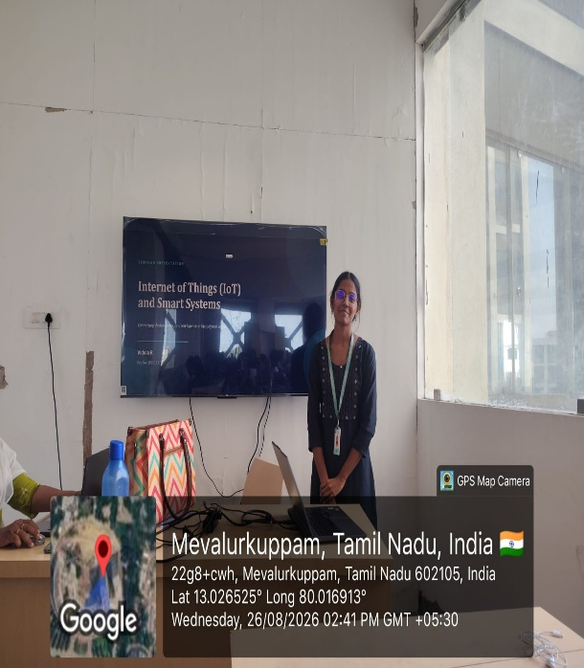
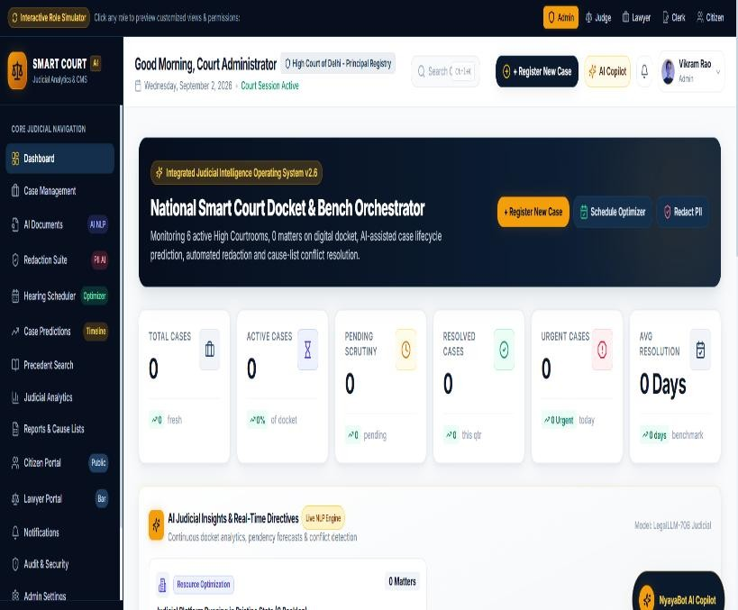

Project Description:
The AI-Powered Smart Court Case Management and Judicial Analytics Platform is an intelligent digital system designed to improve the efficiency, transparency, and speed of court case management. Traditional court systems often face challenges such as large numbers of pending cases, manual document processing, difficulty in tracking case progress, scheduling conflicts, and delays in judicial decision-making. This proposed platform uses Artificial Intelligence (AI), Machine Learning (ML), Natural Language Processing (NLP), Data Analytics, and Cloud Technologies to support the management and analysis of judicial cases. The system can digitally store and organize case records, automatically classify legal documents, track case progress, schedule hearings, identify case delays, and provide analytical insights to judicial administrators.
Individual Contribution: I was responsible for analyzing the overall requirements of the AI-Powered Smart Court Case Management and Judicial Analytics Platform. I defined the project objectives, identified the major modules and users, and prepared the overall system workflow. I coordinated the activities of the team members and ensured proper integration between different modules. I also reviewed the final system and contributed to the overall project planning and documentation.

Student Signature Guide Signature

